General Guide
Documentation of the Pokemon Dream World

The Pokemon Dream World was a part of Pokemon’s website, under Pokemon Global Link. During the 5th Generation, players who owned Pokemon Black, White, Black 2, Or White 2, could link their Pokemon Games into their Pokemon Global Link Accounts to access the Pokemon Dream World.

In order to access the Dream World, a player had to enter a building maintained by the Dream Scientist Fennel*1. By speaking to Fennel, they could put a pokemon in their team to sleep. Once a pokemon is put to sleep, the player can then access a tab under Pokemon Global Link named Pokemon Dream World. The pokemon put asleep would be seen as the player’s partner pokemon in the Dream World.

The Pokemon Dream World was where players could have found pokemon with hidden natures, pokemon with egg moves, and even farm berries like the 3rd and 4th generation. In addition, the Dream World also included a home island with a house the player could decorate. Players could also visit other player homes to water their berries for better crop yields and see their interiors.
https://www.thonky.com/pokemon-black-white/dream-world#visiting-the-island-of-dreams
1* Fennel is the scientist’s name in English. Different languages change her name around, like Vivian for the German Language

Pokemon in Sub Areas
All the pokemon that can be found in each area (in german)

Partner pokemon (pokemon put asleep in the b,w,b2,w2 games) affect how often a player would find certain sub areas. For example, if the player put an ice type pokemon to sleep, they would most always encounter the Icy Cave in the isle of dreams.

https://www.bisafans.de/spiele/editionen/schwarz-weiss/dream-world-gebiete.php

Berry Tree Growth cycles
Growth cycle of all the berries (under Gen V tab)

https://bulbapedia.bulbagarden.net/wiki/List_of_Berries_by_growth_time

Catalogue Prices
Reference to how furniture looked on catalogue
(berry prices for all as well, but theyre in german)
https://www.bisafans.de/spiele/editionen/schwarz-weiss/dream-world-moebel.php

Minigames
Upon meeting a pokemon in the isle of dreams, the pokemon will ask to play with the player. Each minigame

How all the Minigames function
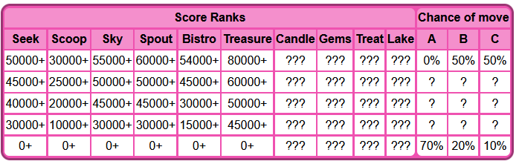

Pokemon are guaranteed after minigame regardless of score, Only affects moves, all natures are hidden/rare nature
Move chances (A,B,C) for rarer moves increase the better the score for the dream world
Bulbapedia has all the score calculations of ALL the minigames, what values are considered, everything.
https://bulbapedia.bulbagarden.net/wiki/List_of_Pok%C3%A9mon_Dream_World_mini-games

Sources
https://bulbapedia.bulbagarden.net/wiki/List_of_Pok%C3%A9mon_Dream_World_mini-games

https://www.smogon.com/ingame/guides/dw_guide

